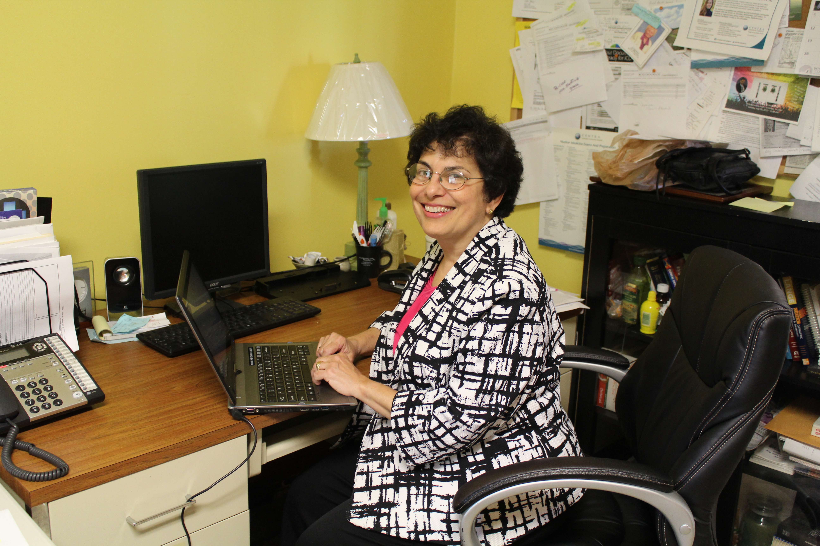

Dr. Mary Cabrera, a Welcomed Addition to the
Lunenburg Health Service, Inc. Board of Directors

Dr. Mary Cabrera began her tenure on the Board of Directors of the Lunenburg Health Service, Inc. in July of 2014. She is the latest in a distinguished line of medical professionals to share her time, knowledge, and expertise with the Health Service.

Dr. Cabrera began practicing in Victoria with the Centra Medical Group upon the retirement of beloved Victoria physician, Dr. Lewis W. Bridgforth, who served on the Health Service Board of Directors for nearly 50 years. Upon his retirement from the Board in 2014, Dr. Cabrera enthusiastically agreed to fill the vacancy.

Dr. Cabrera was born in Louisville, Kentucky while her father was doing a pediatrics residency there. She lived in Cuba until age nine when she came with her parents to the United States. She grew up in West Virginia, New Jersey, and Florida.

Dr. Cabrera attended Smith College and did her premedical studies at Bryn Mawr College. She received her medical degree from the University of Miami Miller School of Medicine in 1989 and did her Residency in Family Medicine at Duke University Hospital. She has been a practicing physician for 26 years and speaks multiple languages, including Spanish and French.

Dr. Cabrera and her husband, Fred Wells, a software developer, have two sons, Caleb, age 21, and Ian, age 18. They reside in Chesterfield, Virginia.

